Overview of Different Collection Types Framework in Java (list,set,map)
what is collection : a collection is an object that holds other objects
How to study data structure ?
1) Logical view //what
2) Operations //how
3) Cost of operations //time
4) Implementation //code
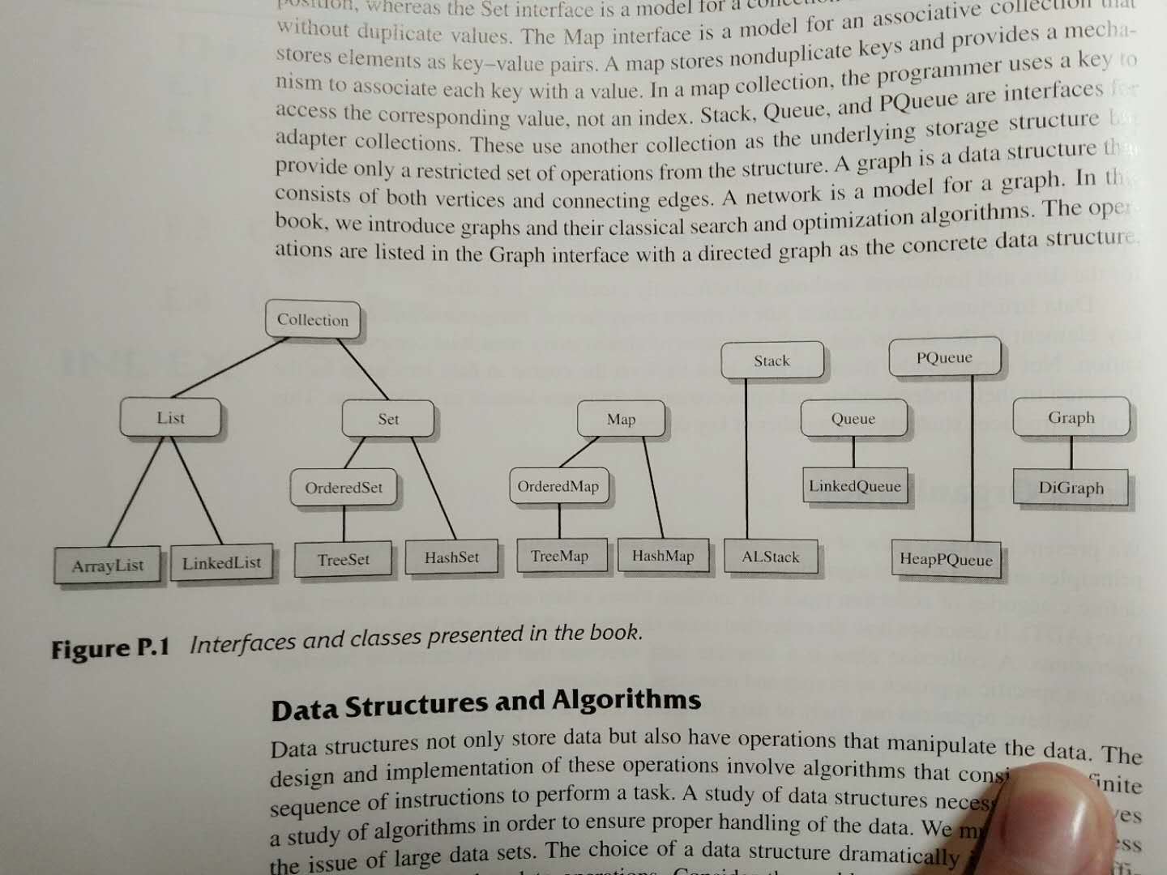
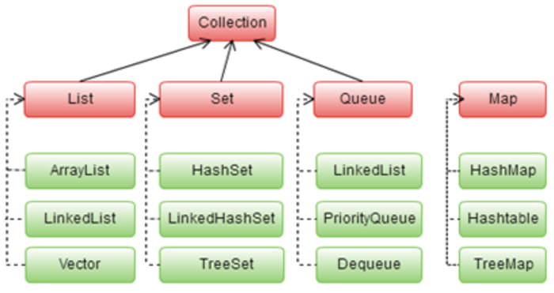
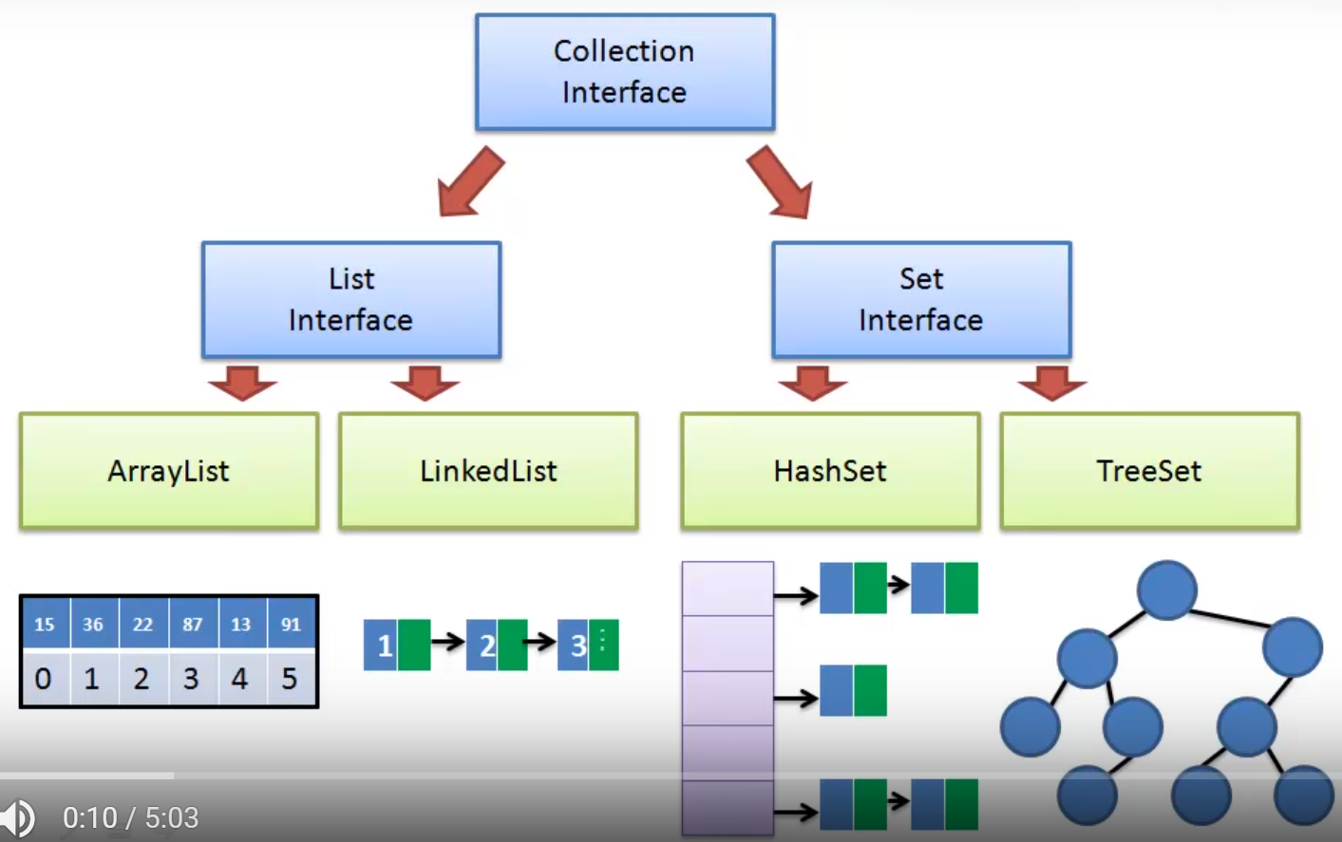

Map Collection
normal map digraph consist:
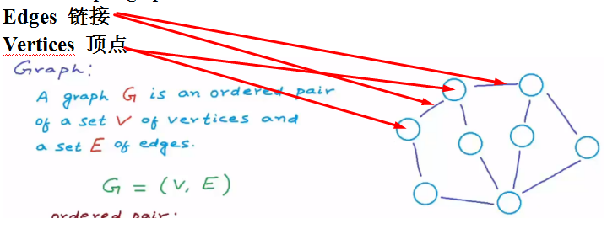
-weighted directed graph(digraph) 每个链接有权重有方向的graph
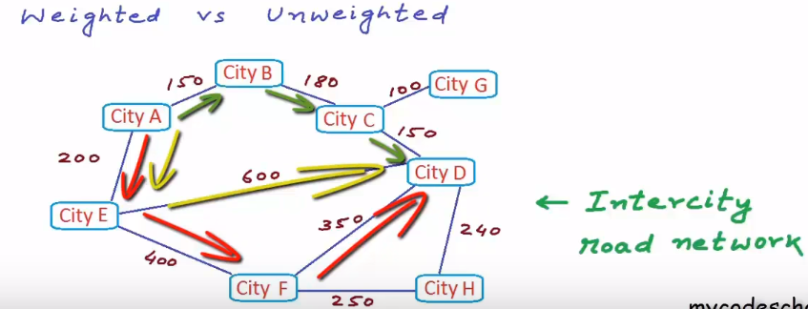

Queue Collection
First in first out ADT (from from to rear)
stack interface functions:
(these functions runs at the constant time or O(1)
.Enqueue(x) // push x on to the top of the stack
.Dequeue( ) //remove the top element on the stack
.front( )/peek( ) //returns the top element on the stack
.IsEmpty( ) //check if a stack is empty
.IfFull( ) //check if the queue is full
- priority queue data structure(DS)
In a priority queue adapter, an item can enter the structure in any order ,but data must be removed in order of priority.

Stack Collection
stack abstract data type(ADT) is list with the restriction that insertion and deletion can be performed only from one end , called the top.

stack interface functions:
(these functions runs at the constant time or O(1)
.push(x) // push x on to the top of the stack
.pop( ) //remove the top element on the stack
.top( ) //returns the top element on the stack
.IsEmpty( ) //check if a stack is empty

Map Collection
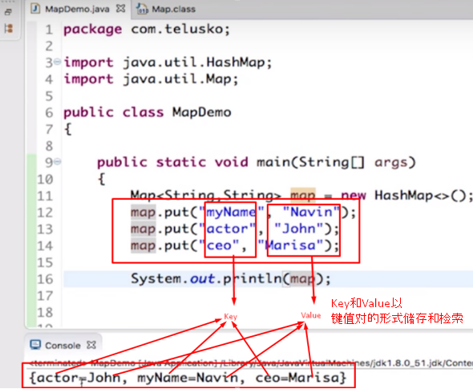

Array List
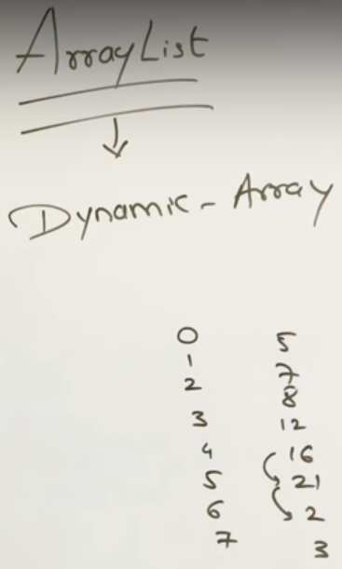
Difference between array and arraylist:
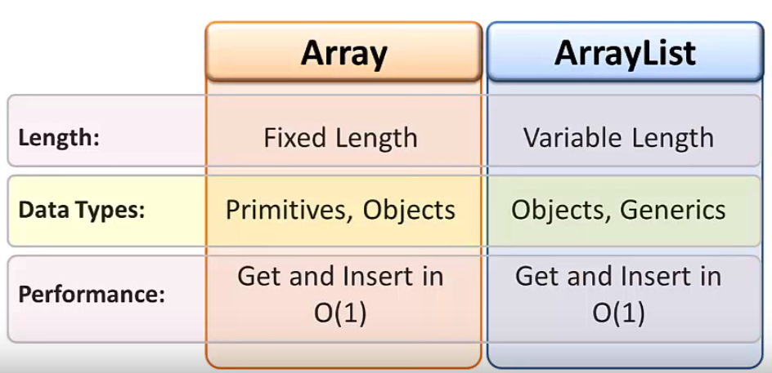
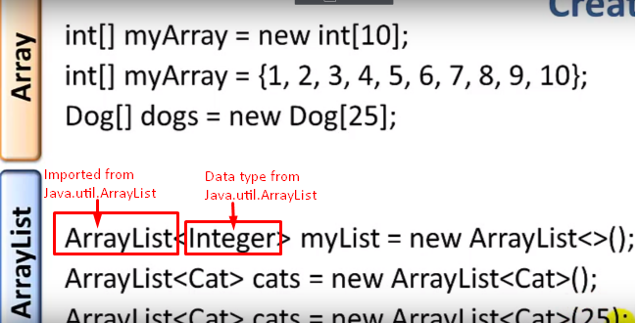

Linked List
how link list works in memory
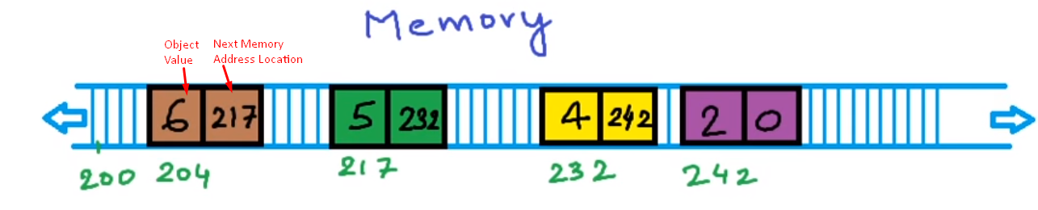
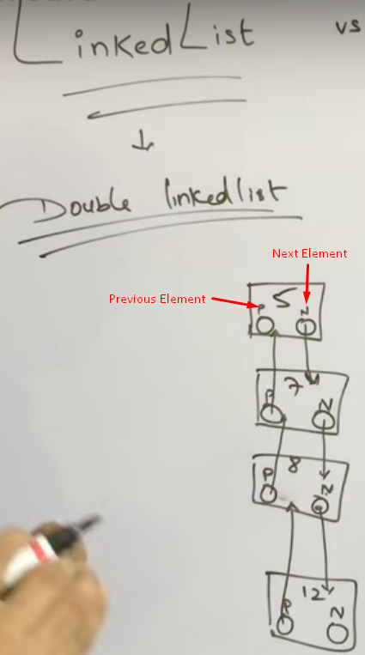

Set List
Hash Set list doesn’t support duplicate value 任何set和map类型都不能保存重名元素
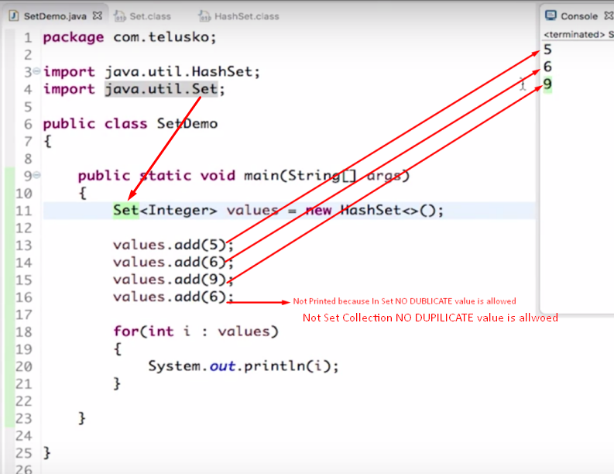

If a list collection length n :
the first element is at position 0, the second element is at position 1 ... the last element is at position n=size( ) - 1.

